Assignment 1

Environment Used:

PyCharm Professional with Windows Subsystem for Linux (WSL).

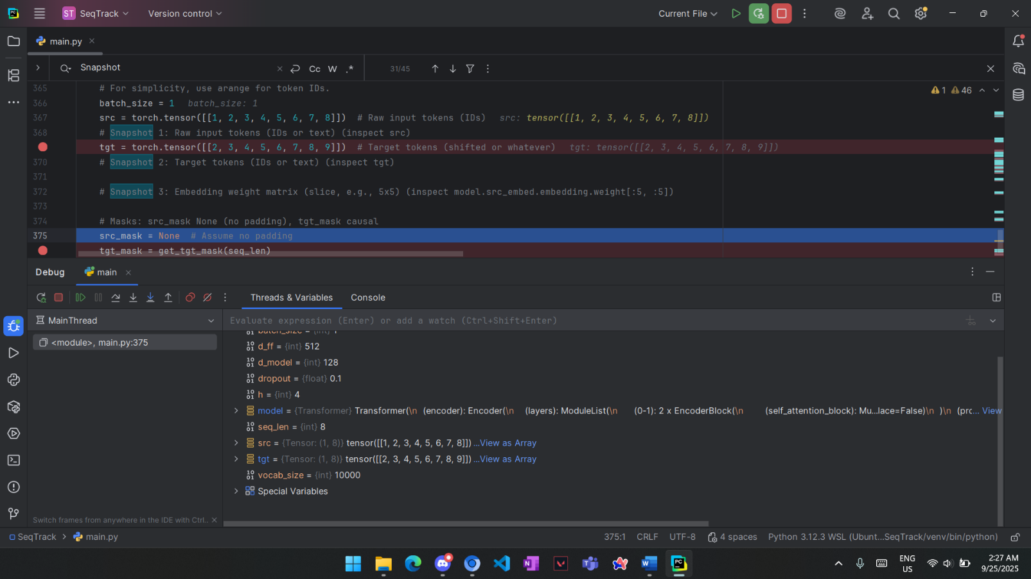

Debugging Walkthrough:

**Input & Embeddings:**

Snapshot 1, 2 (Input & Target ids):

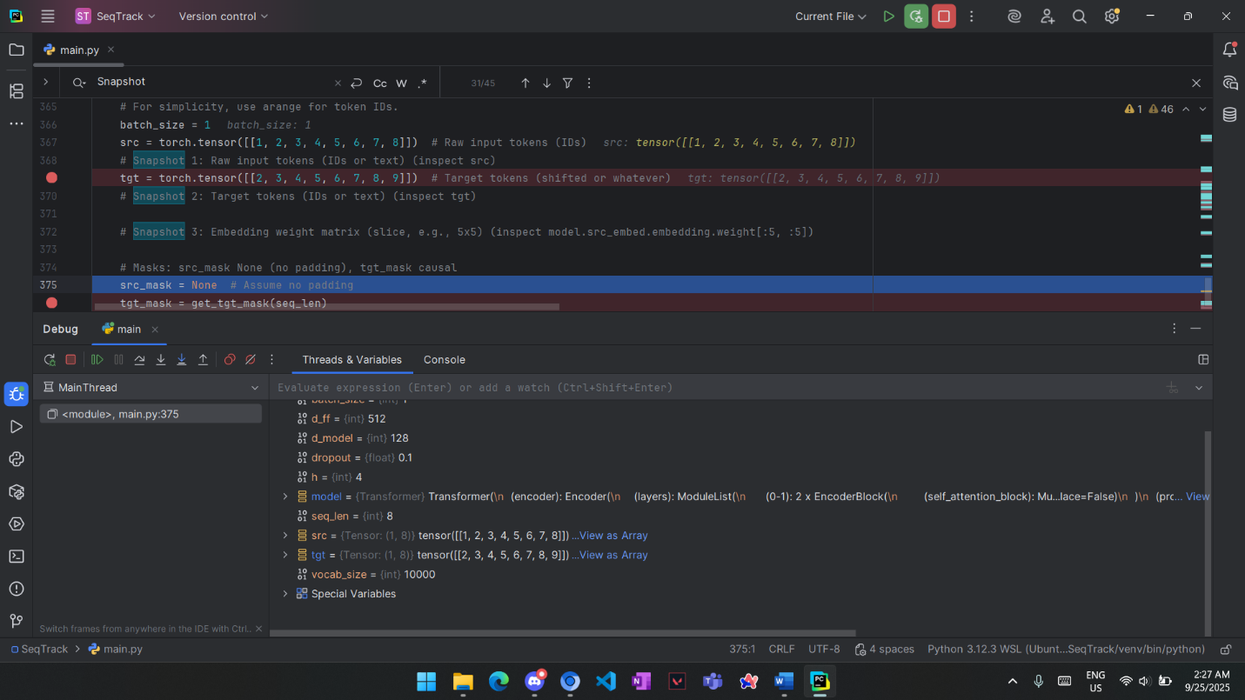

Src is a tensor of size (1, 8); 1 sequence of 8 tokens.

Tgt is a tensor of size (1, 8); 1 sequence of 8 tokens.

Snapshot 3 (Embedding weight matrix):

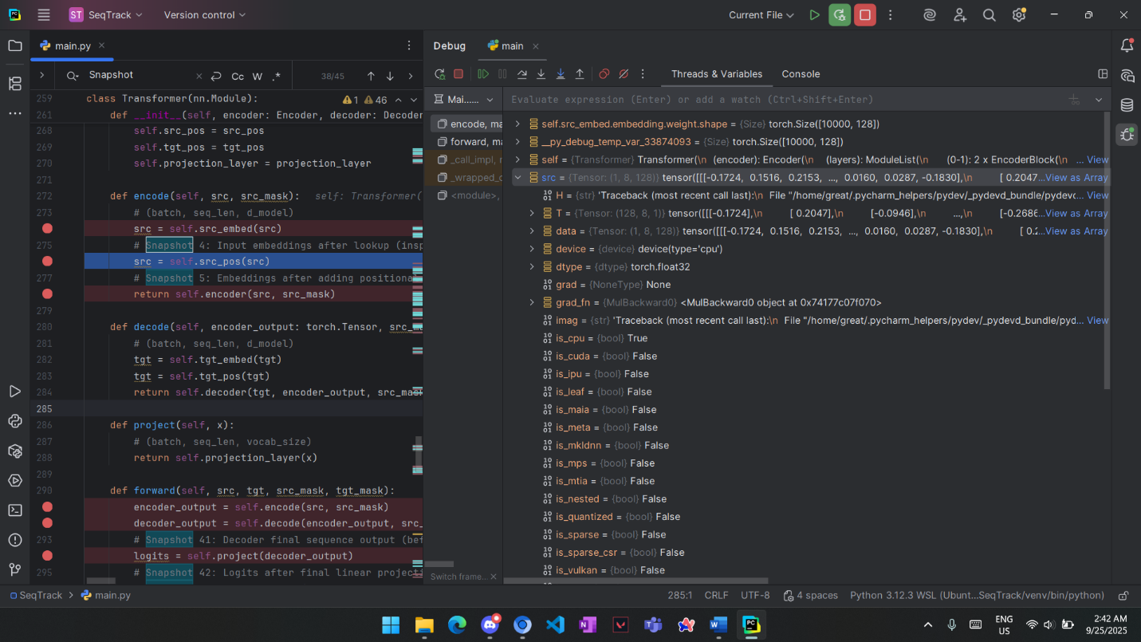

Embedding matrix is of shape (10000, 128), 10K Vocab size each represented by a 128-sized vector.

Slice of the values:

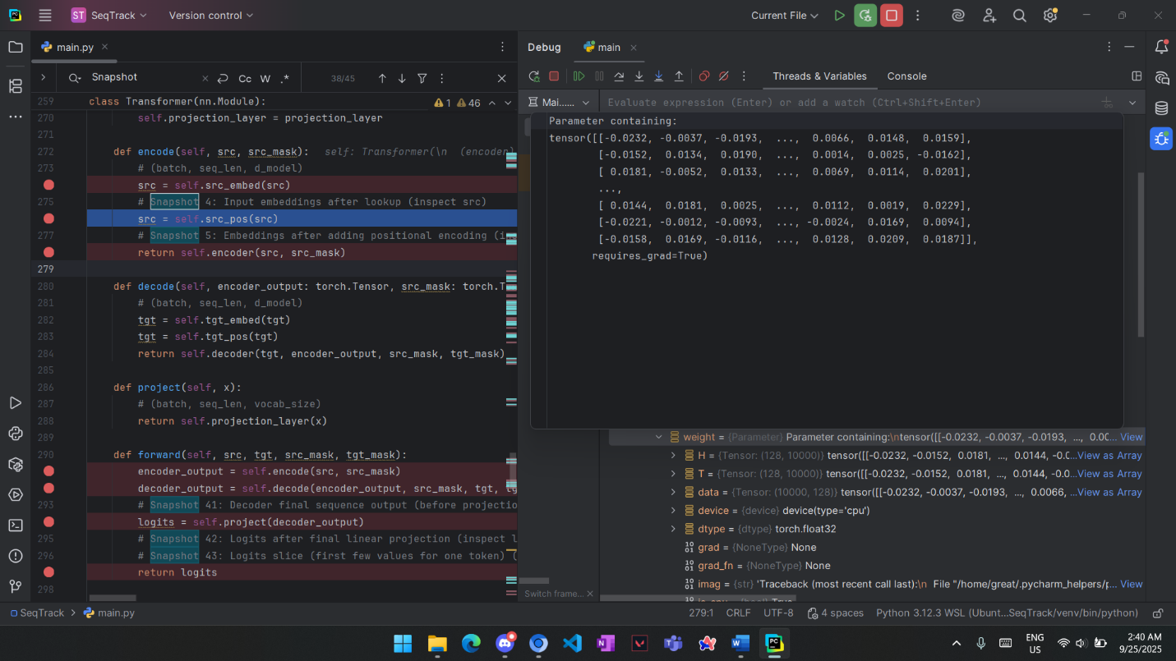

Snapshot 4 (Input after embeddings lookup):



Each input id is replaced with a 128-sized embedding vector. To get a matrix of size (1, 8, 128).

Embedding size is fixed as it’s chosen to capture meanings of the words, independent of number of vocabulary or tokens.

Snapshot 5 (Embeddings after positional encoding): 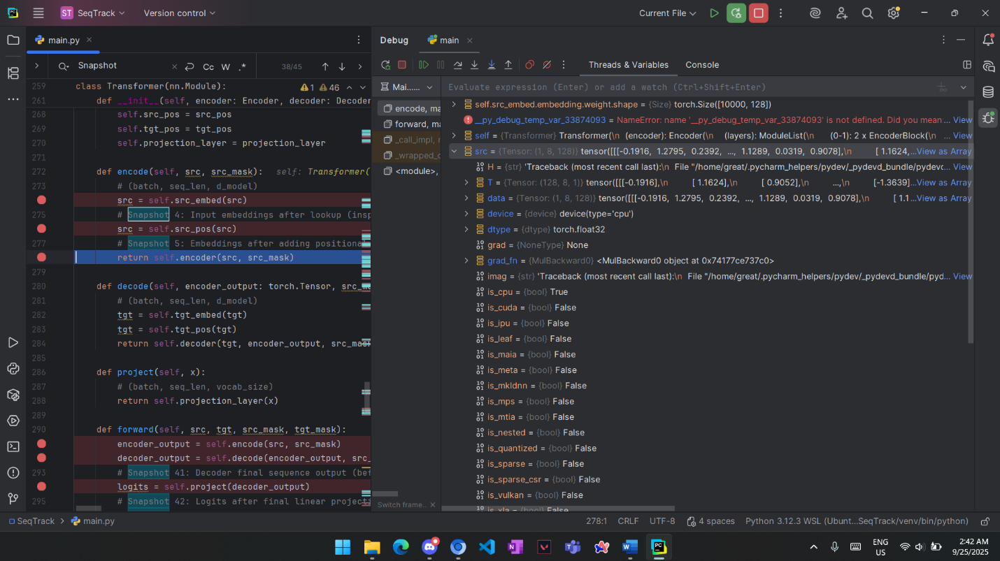

Positional encoding is applied to the embeddings to capture information about the token position in the original sentence.

The tensor is same shape as previous step (1, 8, 128) but values are different.

**Encoder:**

Snapshot 6 (Encoder input):

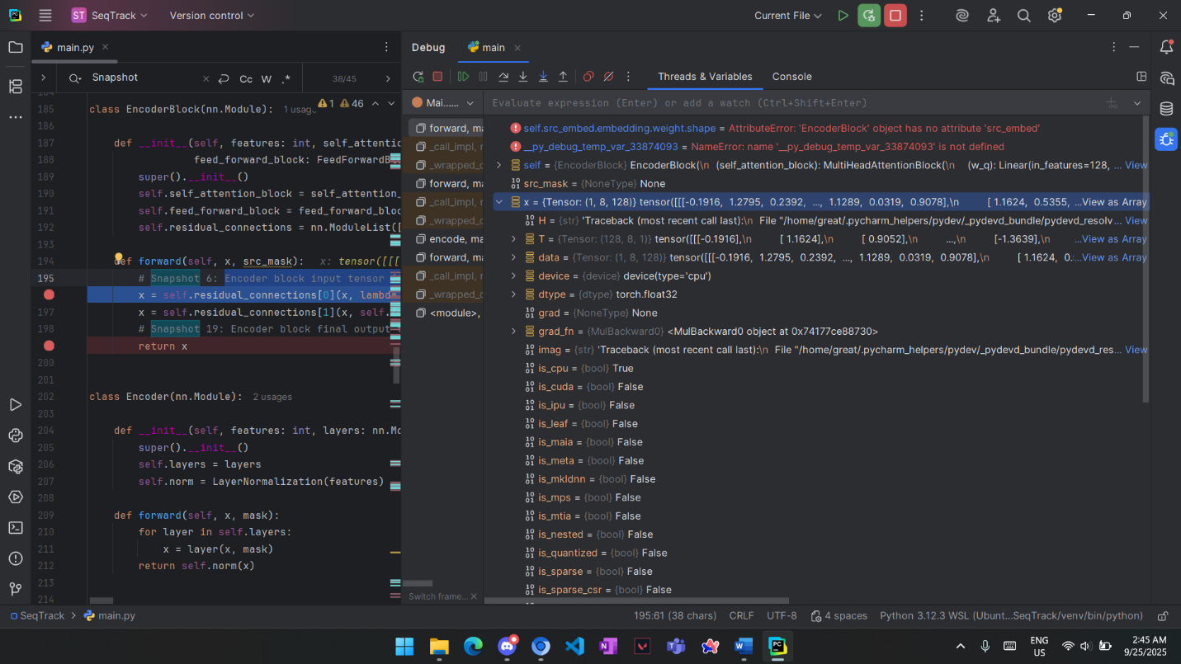

X is the input to the Encoder block, a tensor of size (1, 8, 128), which is output of embeddings + positional encoding step.

Snapshot 7, 8, 9 (Q, K, V): 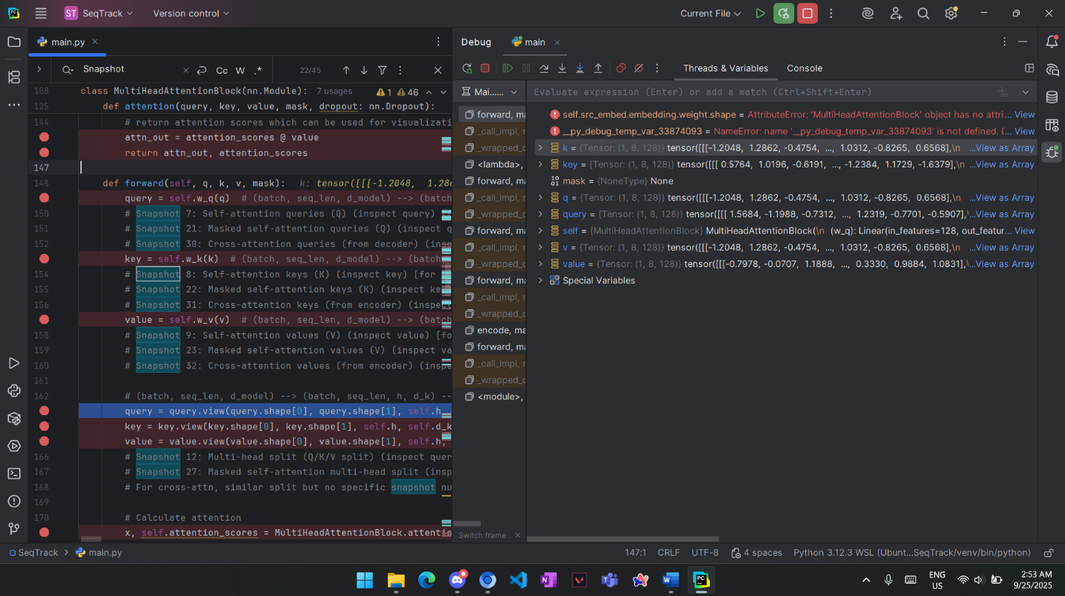

In the MultiHeadAttention block, Input is copied into three matrices of same size and values. Query, key, value are the matrices after weights multiplication.

Snapshot 10 (Attention scores before softmax):

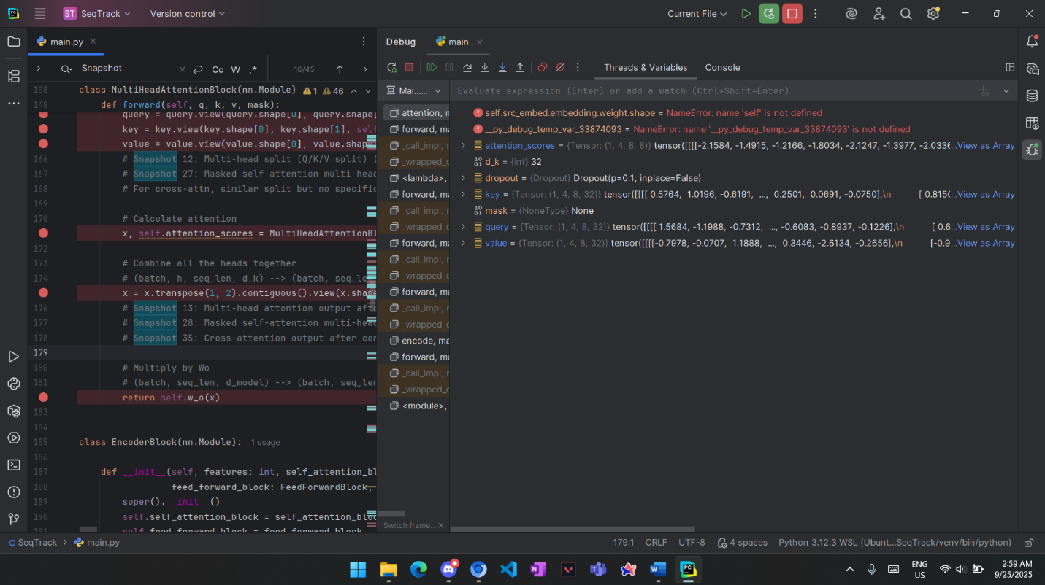

Attention scores are computed by multiplying K, Q divided by sqrt(dk), where dk is the size of a single head.

Shape is (1, 4, 8, 8), because we have 4 heads, 8 words importancy for each word.

Snapshot 11 (Attention after softmax):

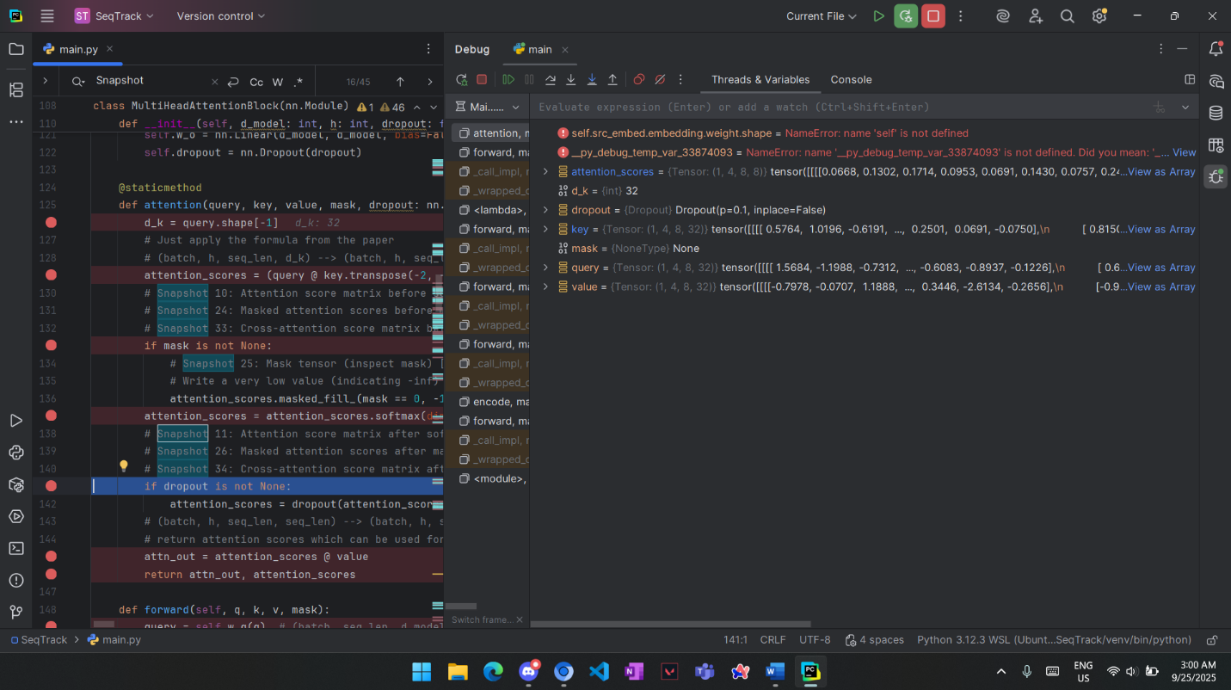

Same size as before but each row sums to one.

Snapshot 12 (MultiHead split):

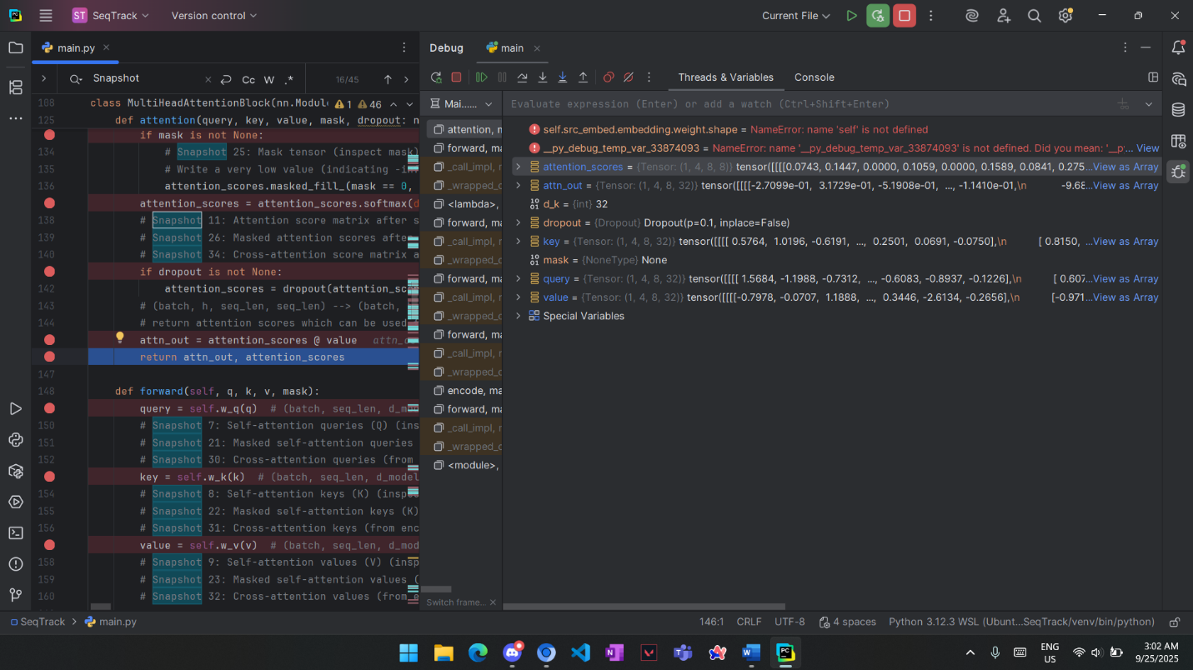

Attention_out is of size (1, 4, 8, 32). 4 Heads each 8 words and 32 is part of the embedding.

To make each head capture information from different aspects of the word.

Snapshot 13, 14, 15 (After Concatenation, After norm layer, Res Connection):

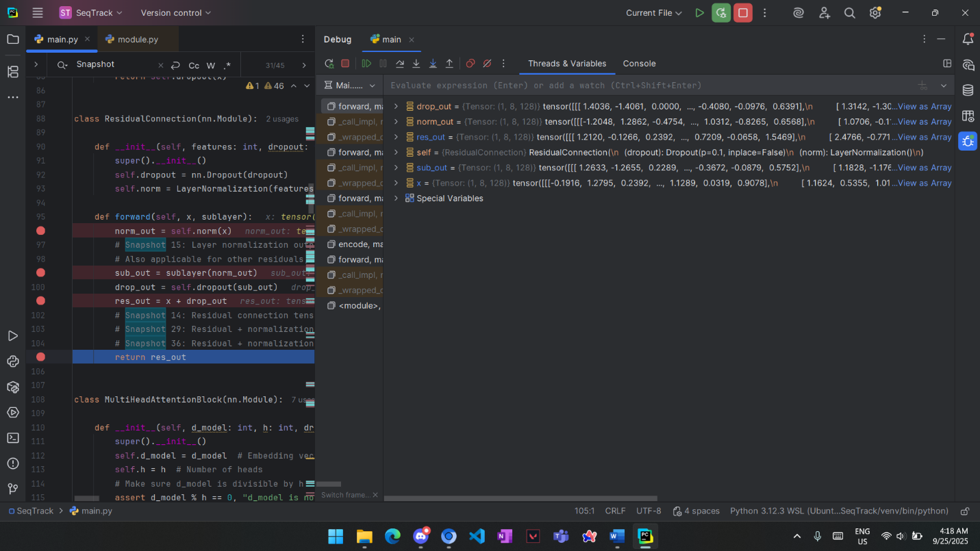

Sub_out is MultiHeadAttention output after concatenating all heads. to get the same size as input (1, 8, 128).

Norm_out is the input passed to a normalization layer. Of size (1, 8, 128)

Res_out is output of ResidualConnection which is sum of AttentionOutput and Input. of size (1, 8, 128)

Shapes are preserved as attention layer multiplies attention score matrix by matrix V then concatenated to produce tensor of same shape as input. ResConnection summation does not affect the shape.

Snapshot 16, 17, 18 (FeedForward Netwok):

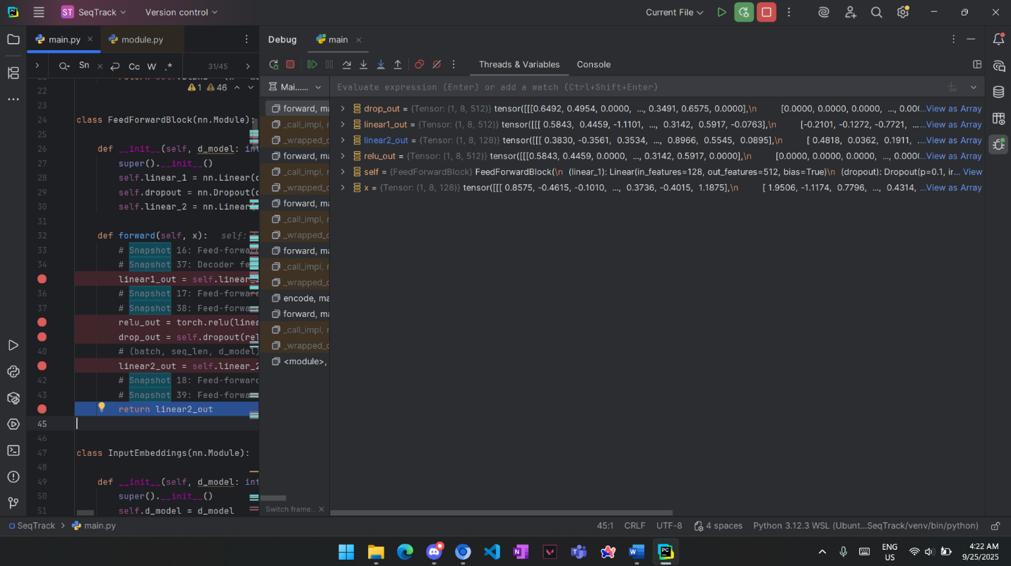

X is output of ResidualConnection, it’s passed to a two linear layers.

X, Linear1 size of (1, 8, 512), Linear2 of size (1, 8, 128).

Snapshot 19, 20 (Encoder Output, Decoder Input):

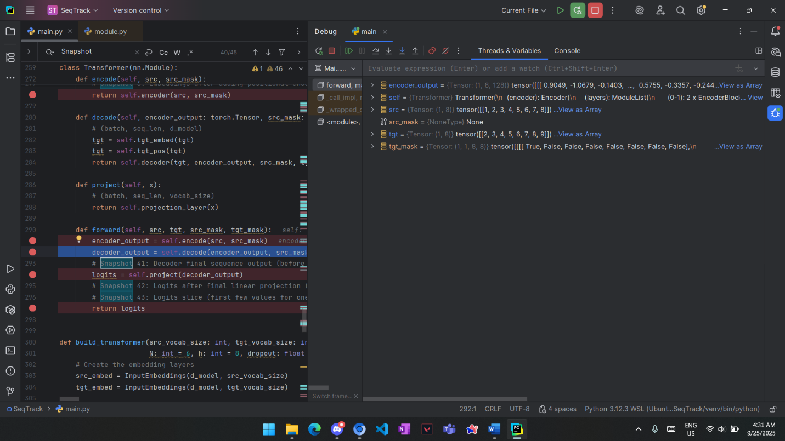

Encoder output is the input for the decoder of size (1, 8, 128)

**Decoder**

Snapshot 21, 22, 23 (Q, K, V):

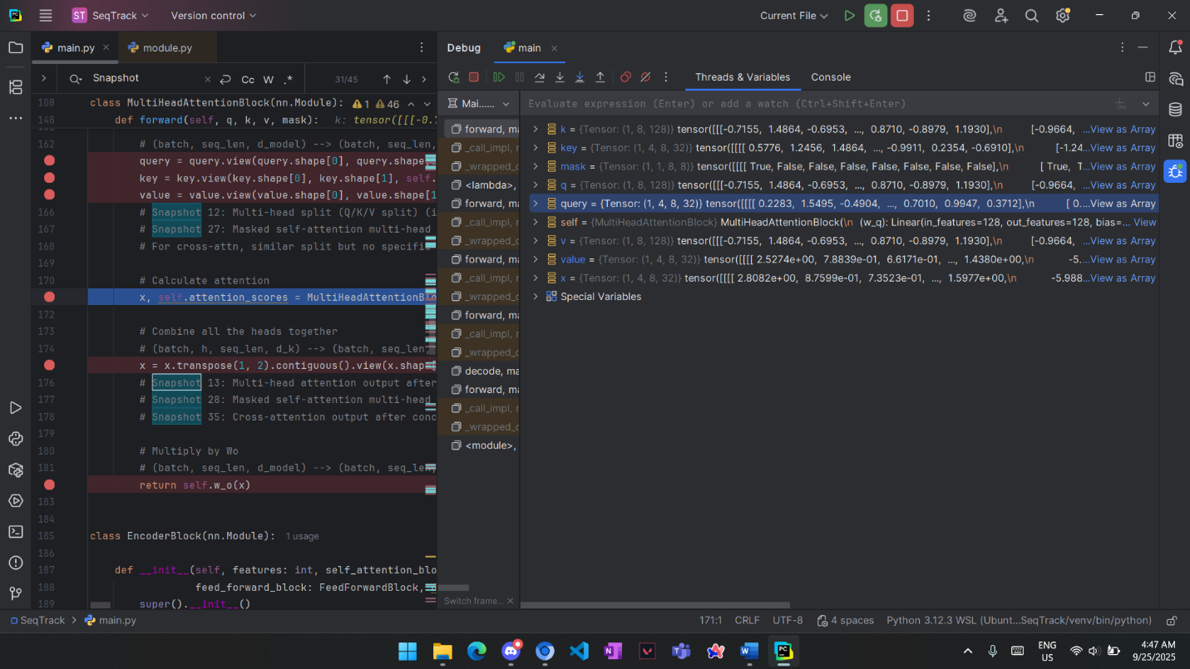

Q, K, V matrices of size (1, 8, 128). They are not masked as in this implementation, masking take place after calculating Attention scores.

Snapshot 24 (Attention before masking):

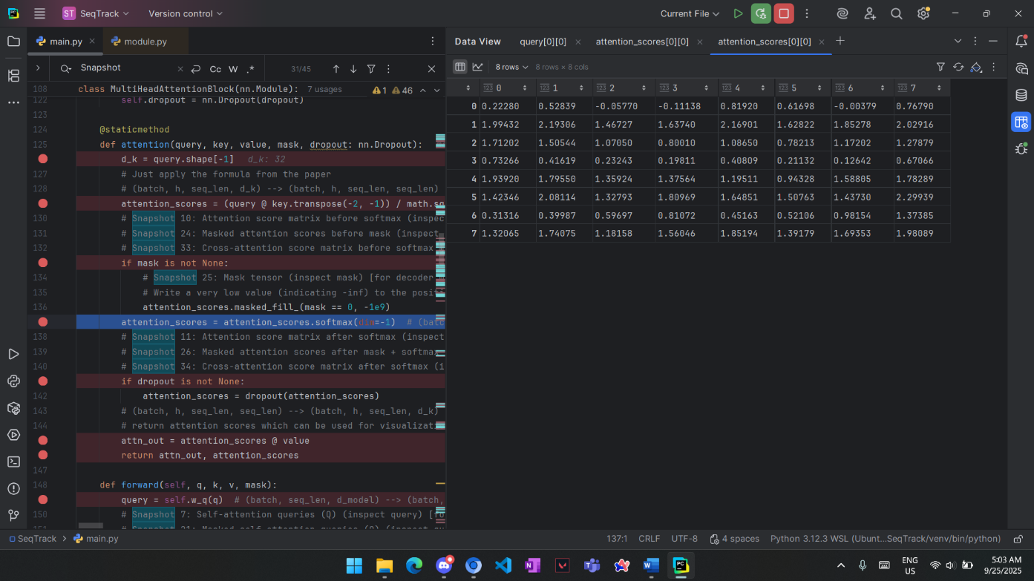

These are attention scores before masking, We need to mask future words from thee decoder, They are the values above the main diagonal. We replace them by -inf to be zero after softmaxing.

Snapshot 25, 26 (Mask tensor, Masked attention after softmax):



Mask tensor of size (1, 1, 8, 8). For each word what words we need to mask.

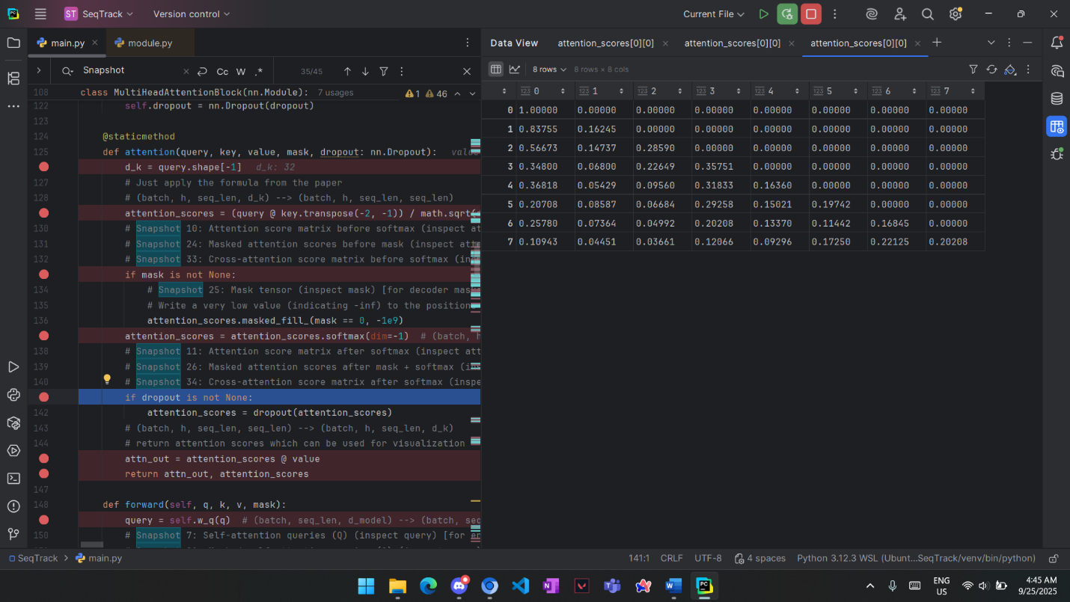

Masked Attention after softmax of size (1, 1, 8, 8)

Snapshot 27, 28 (MultiHead split before and after concat):

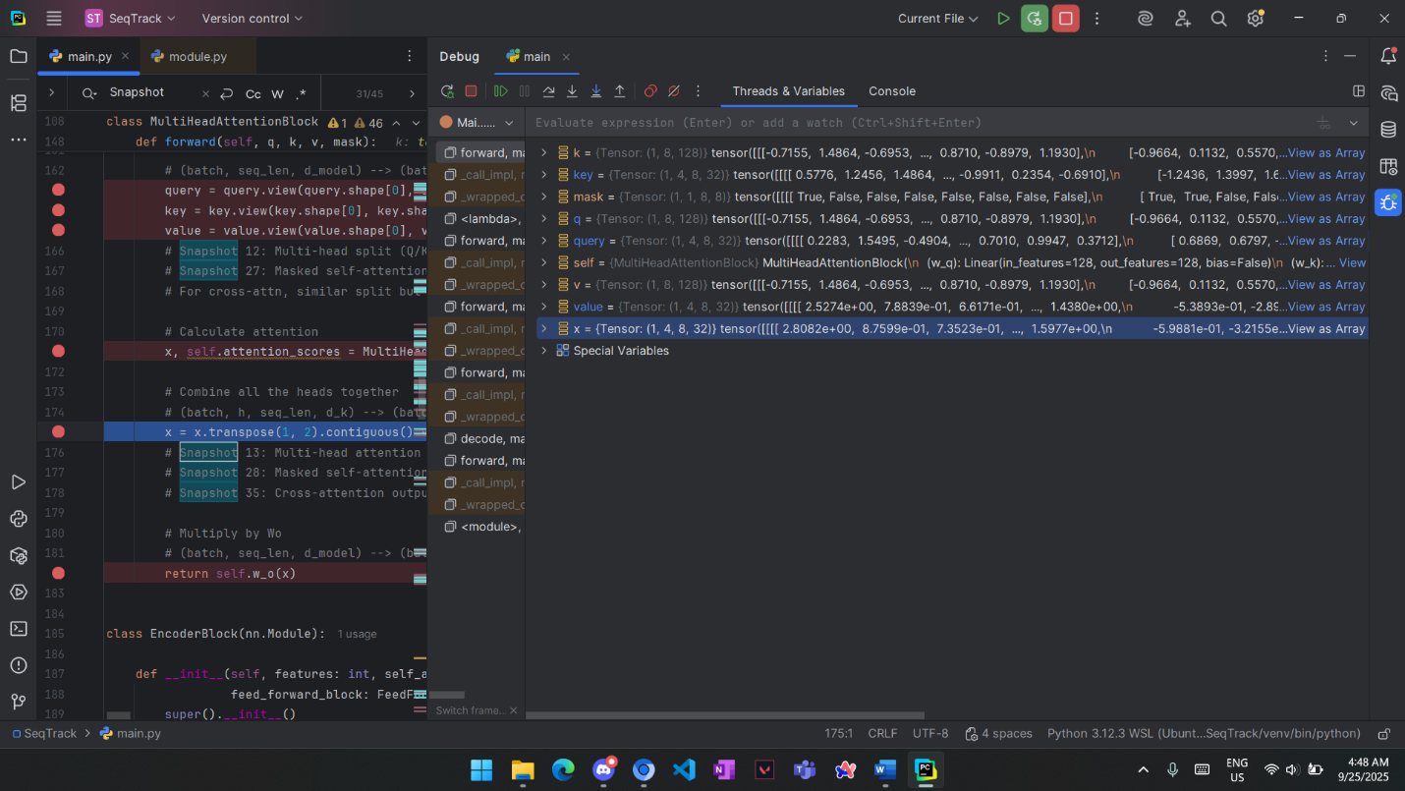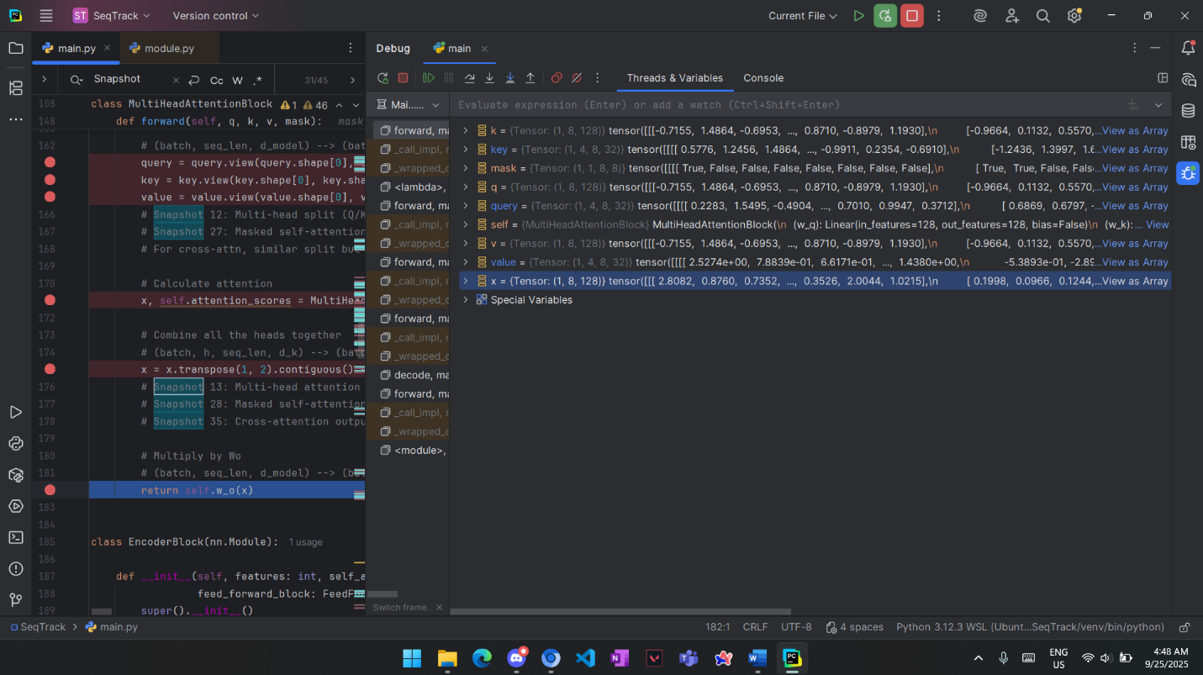

Before concat, 4 heads each of (8, 32)

After concat (1, 8, 128)

Snapshot 29 (ResConnection output):

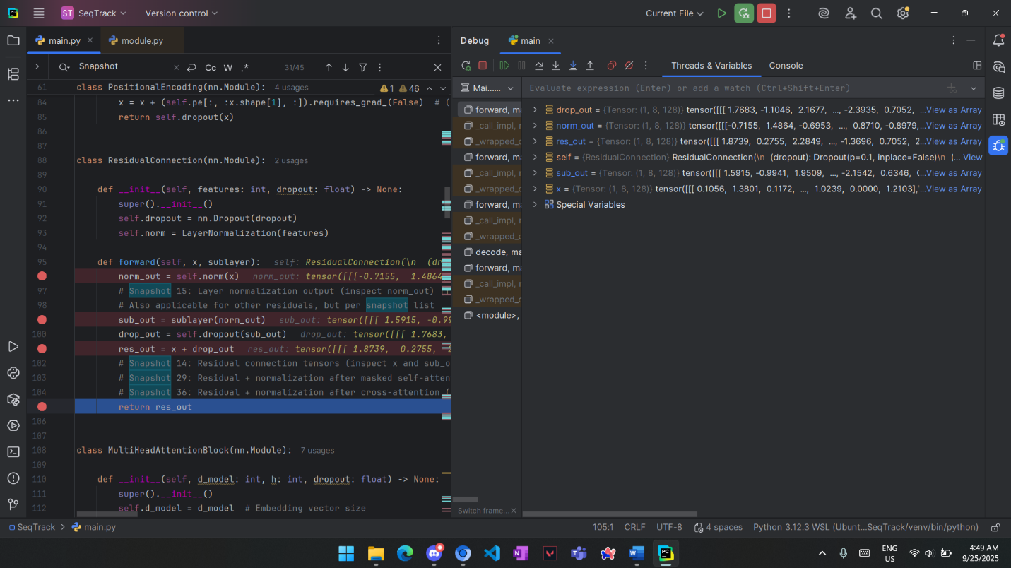

Res_out is output of Masked MultiHeadAtt + input.

Snapshot 30, 31, 32 (CrossAtt Q, K, V):

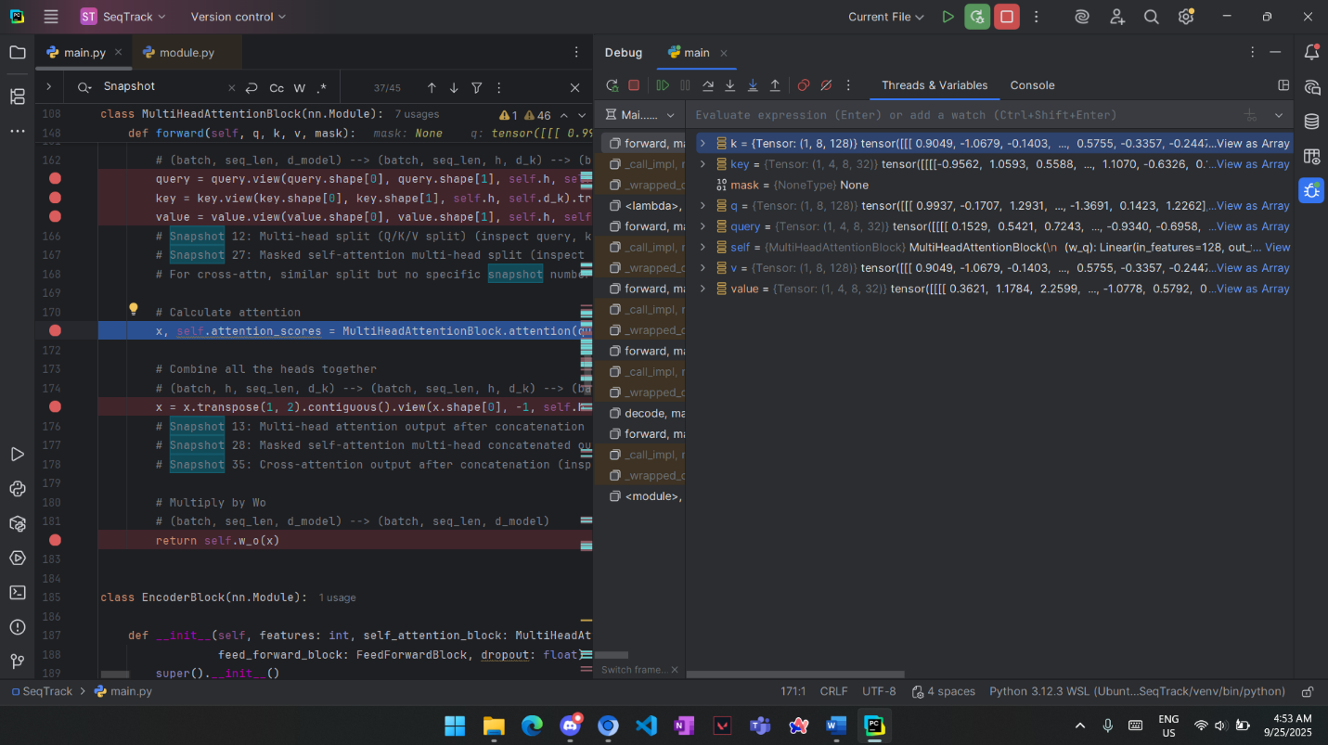

K, V are the same value as they are output of encoder but values differ in Q as it is output of previous ResConnection. They are all same shape of (1, 8, 128).

Snapshot 33, 34 (CrossAtt before and after softmax):

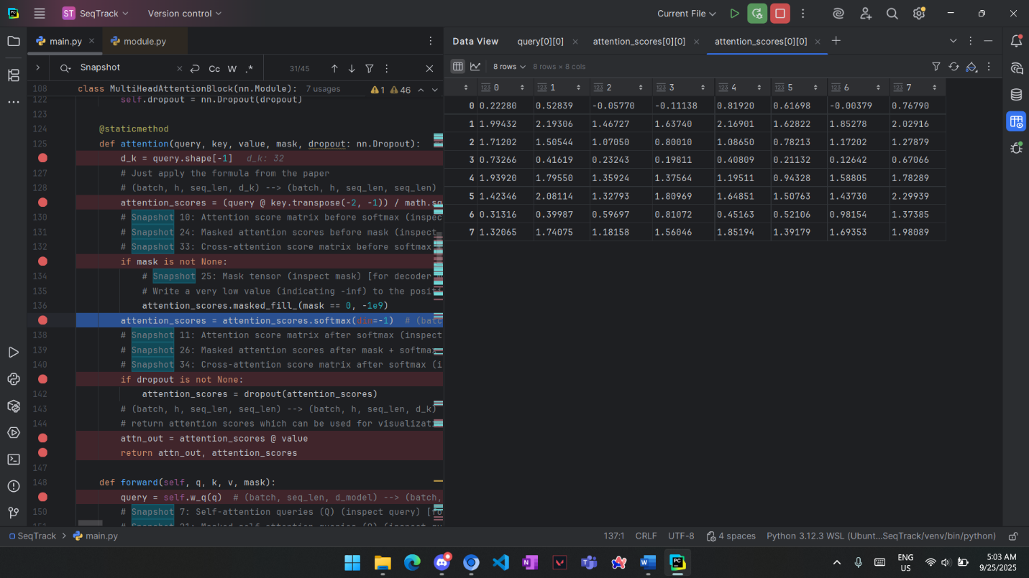

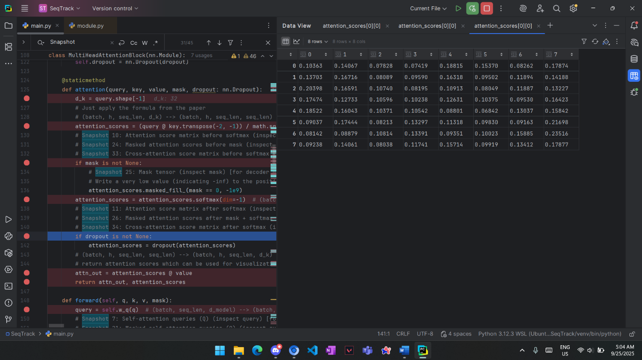

Snapshot 35 (CrossAtt after concat):

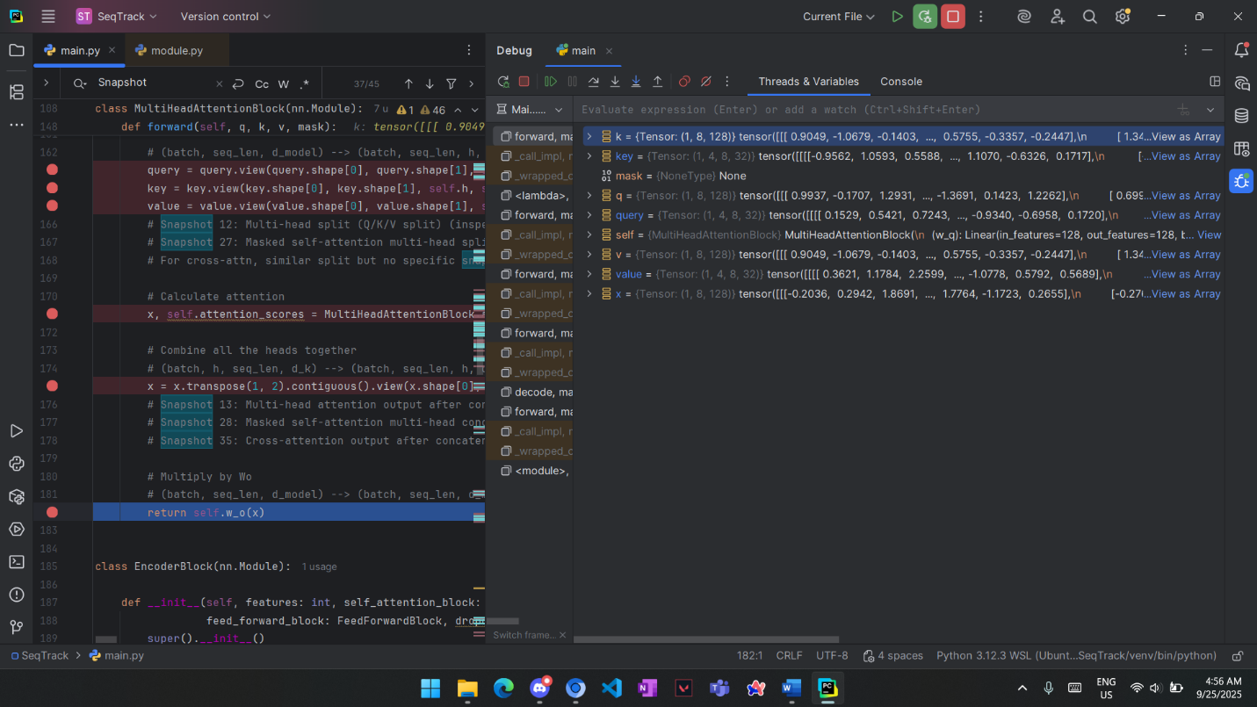

Of size (1, 8, 128).

Snapshot 36 (ResConnection Output):

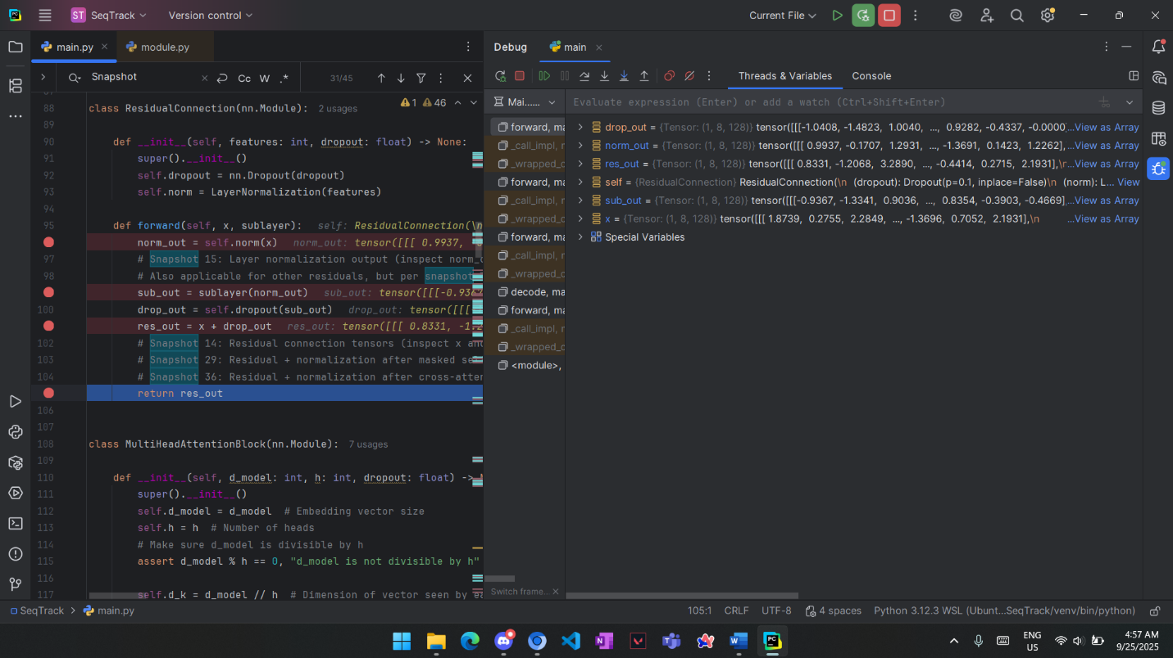

Res_out is output of CrossMultiHeadAtt + block input.

Snapshot 38, 39 (FeedForward Network):

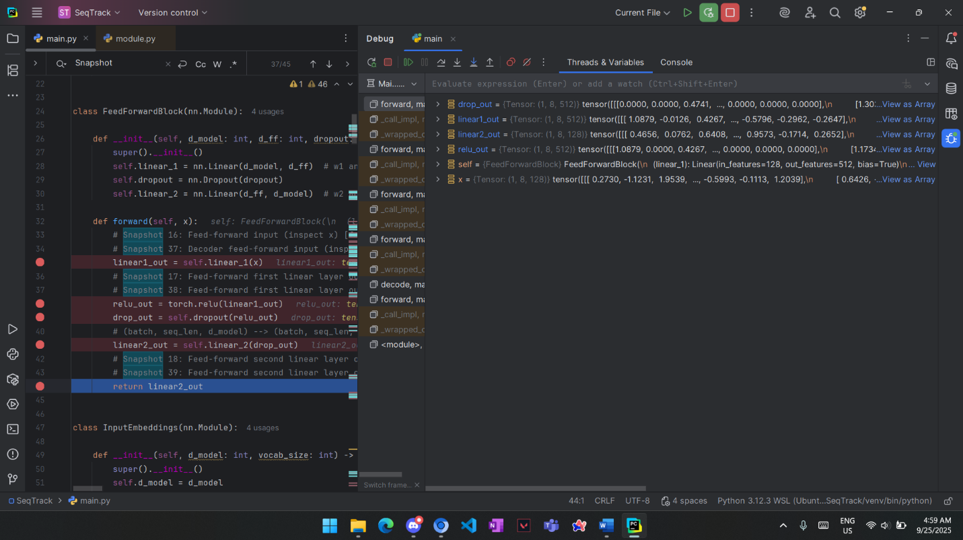

Linear layers 1 has same shape of (1, 8, 512), layer 2 (1, 8, 128).

**Final Output**

Snapshots 40, 41, 42, 43 (Decoder outputs):

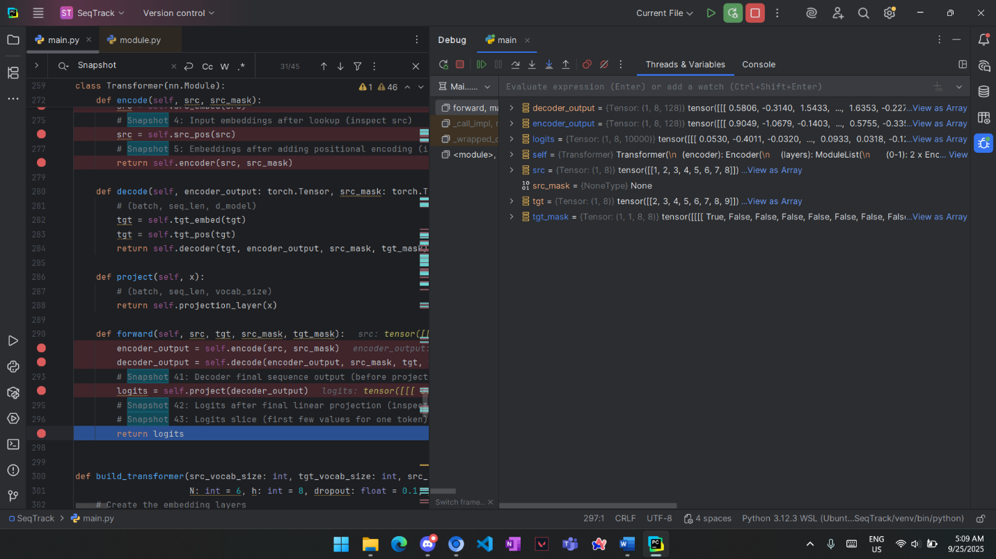

Decoder_output is final sequence output of size (1, 8, 128), also the logits before projection

Logits are projection of decoder ouput into size (1, 8, 10K) via a fully connected layer. 8 is the target length, each one has a probability dist. of all vocab words.

Logits slice:

